**Pre-proposal**

**Coatings for Offshore Foundations and Mariculture Installations with Mechanical Strength and Foul Release Properties**

Status 16.03.2017

**Fouling on offshore structures and installations**

Actually, and with increasing numbers offshore installation in European waters and in overseas territories have been and will been installed ranging from offshore wind farms to underwater ocean energy turbines and mariculture nets and cages. Even approx. 1600 turbines are authorized for construction on the German North Sea territory. The foundations are prone to fouling and corrosion building artificial reefs and offering to thousands of benthic organism suitable substrates for settlement, growth and propagation. In front of soft bottom coasts like in the North Sea with rare natural substrata foundations made of steel, concrete or polymers favor the establishment of benthic taxa which were unknown in these marine regions or present at low abundance. The fouling of the foundations of oil rigs is well known since decades but these rigs were neither coated nor should they have service times of 25 years or more. Semi submersible rigs are movable and can be repaired in dry docks at costs of easily more than USD 1 million/d. Up to now it is not intended to move foundations of wind farms which have to be cut and totally removed after a service life of 25 years and more. Fouling occurs on submerged surface in relation to depth, currents, temperatures and region. The most critical zone is situated from the surface of the water and down to 5 m. Abundant fouling communities develop here with dominantly mussels, small crustaceans and barnacles. The wet weight of fouling may reach values of 40 kg/m2 and more. Due to currents and wave impact the outer layers of the upper fouling community are regularly removed and sink to the bottom where they may induce around the foundation anoxic conditions caused by excess of oxygen demand during degradation. The fouling near the water surface is of primary concern for offshore installations in relation to an increase in friction and weight relevant for the stability. 5 m below the surface the composition of the fouling community is variable but mostly composed of soft corals like anthozoa, hydrozoa and bryozoa depending on the region. 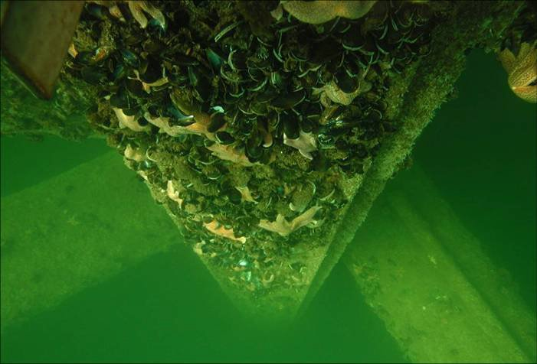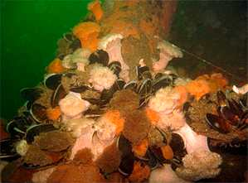

Fouling on offshore structure near the surface (left) and at 10 m depth (right).

Source: Schröder et al. 2013 (left), IWES, 2010 (right)

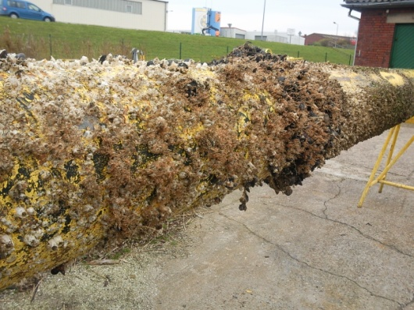

Fouling on hydrographic monitoring device submerged down to 10 m of the island Norderney, North Sea. Source: LimnoMar

The question of the relevance of fouling development of offshore foundations are actually intensively discussed as the challenge to keep them totally free of fouling and remove regularly the community for inspections purposes on corrosion pushed maintenance costs to non-economic levels. To reduce these costs coatings with self cleaning properties or easy-to-clean properties shall be developed. Anti-corrosion coatings have to stand mechanical impact of drifting ice and matter, should be UV resistant and should not be penetrated by fouling organisms like barnacles or oyster shells. In the upper layers of water surface and 5m depth self-cleaning properties would ideal, but when they have to be cleaned for inspection and to improve stability of i.e. the turbine, they should be strong enough to withstand the rigors of underwater cleaning impact. To facilitate the cleaning and inspection the coatings themselves should be strong, reduce the adhesion of fouling organisms thus facilitate the regular removal of the fouling community.

**Fouling problems in Mariculture**

According to FAO, the aquaculture industry is the fastest growing global sector in food production 1. Meanwhile, the industry produces nearly 50% of the world's food fish. The demand for healthy seafood and fish can no longer be covered exclusively by the natural resources. Sustainability and the preservation of natural resources play a crucial role in further growth. Not least, this point also interacts with consumer acceptance. However, the product quality and the price are the most important factors for consumers.

In addition to land-based systems and pond-farming, open water aquaculture plays an important role, especially for popular fish such as salmon. These free-water-based aquacultures usually use net cages. Although the design of these cages has been state of the art, the costs for maintenance and operational costs are comparatively high.

This is to a large extent due to the undesirable growth of the nets by marine organisms (Biofouling). The direct economic losses are 5-10% of the production costs 2. The fouling entails some decisive disadvantages for mariculture. On the one hand, the biofouling on the net cages generates a weight increase by as much as two-hundred-fold within a few months. During the same period the drag increases by 5 fold3. On the other hand, the biofouling causes a closure of the net mesh, which adversely affects the flow of oxygen between the open water and the net cage. Fish health and, last but not least, product quality are directly affected. Oxygen deficiency can lead to an increased stress level of the animals, with a consequent loss of quality or even death 4.Another elementary aspect, especially for salmon farms, is the influence of fouling on the occurred nce and spread of diseases and parasites. The most serious problem is currently the Copepod *Lepeophtheirus salmonis*. The parasite causes lesions, disrupts the osmoregulation of the animals, promotes secondary infections and can have fatal consequences in the case of massive occurrence. The cost of the sea lice control amounts to 0.10 - 0.25 € per kilogram of fish 5. Various cleaner fishes are kept in the net cages for the purpose of biological control. However, if the nets are fouled, this pest control only works in a limited way because the cleaner fish favor the organisms on the net. In addition, fouling organisms can also have a direct negative effect on fish health. Hydrozoids and anemones can cause irritation and injury of the skin by their nematocysts.

The state of the art for controlling biofouling in mariculture is made up of inspection, cleaning and the use of antifouling paints. In these antifouling paints preferently the biocides copper, cuprous oxide, copper-thiocyanate, copper-pyrithione, zinc pyrithione, zinc oxide, and tralopyril are used. The use of biocidal antifouling paints affects the environment and generally have an impact on the quality of production, creating residues in the seafood. On the other hand, maintenance and cleaning intervals are increased for untreated nets which lead to significantly increased costs. Cleaning by biological methods, especially by means of grazer fish, can be used as a supplement, but does not completely solve the problem (here also the reference to parasitic problems). Therefore

there is still the need to develop better and more environmentally friendly methods to control fouling in the aquaculture industry.

1 http://www.fao.org/fishery/aquaculture/en

2 Lane A., Willemsen P.R. Collaborative effort looks into biofouling. Fish Farming Int. 2004:34–35.

3 Milne P.H. Fish Farming: A Guide to the Design and Construction of Net Enclosures. Stationery Office Books; London, UK: 1970. Department of Agriculture and Fisheries for Scotland; p. 31.

4 Dürr S., Watson D.I. Biofouling and anti-fouling in aquaculture. In: Dürr S., Thomason J.C., editors. Biofouling. Wiley-Blackwell; Singapore: 2010. pp. 267–287.

5 Costello, M.J. The global economic cost of sea licet o salmonid farming industry. Journal of fish disease, 2009: Volume 32, Issue 1, pp. 115–118.

**Consortium**

The consortium of this proposal comprises industry and research institutes of different expertise and countries.

As raw-material and additive supplier for coatings MOMENTIVE, Leverkusen, Germany will act in cooperation with WOHLERT LACKFABRIK, Bremen, Germany. Both companies will develop coatings which can be applied on bare steel or on anticorrosive coatings for offshore foundations. For mariculture nets, the coatings have to be flexible and applicable by immersion.

The Fraunhofer Institute for Manufacturing Technology and Advanced Materials IFAM, Bremen, Germany, will develop coatings based on its experience in offshore anticorrosive and foul-release coating development.

TNO, Eindhoven, The Netherlands, will contribute nano-composites as functional coating enforcing compounds and additives

MUEHLHAN, France will take part as application specialist to develop suitable techniques for the application of the coatings under development.

LIMNOMAR, Norderney, Germany will conduct simulated field tests at the offshore-simulation station at the island Norderney. To expose coating panels in depths of 10 -12 m, hydrographic monitoring devices on the sea bed will be used which shall be inspected in two-months intervals.

RS AFRICA DIVING, Cape Town, Republic South Africa and MARISCOPE, Argentine, Puerto Montt als manufacturers and service companies for the cleaning of underwater structures of offshore energy installations and mariculture installations will clean test panels off South African and Argentine waters. Both companies run dependencies in Germany which will facilitate the coordination.

Additional companies in contact:

Offshore energy companies

Fish farm Norway

Aquaculture supplier High Comp AS

Fish farm cleaning company MPI Norway

**Literature**

Bruijs MCM (2010) Survey of marine fouling on turbine support structures of the offshore wind farm Egmond aan Zee. KEMA, 34 pp.

Krone, R., Gutow, L., Joschko, T.J., Schröder, A. (2013) Epifauna dynamics at an offshore foundation - Implications of future wind power farming in the North Sea Marine Environmental Research, 85 (2013) 1-12.

Momber, A.W., Plagemann, P., Stenzel, V., Schneider, M. (2009) Investigating corrosion protection of offshore wind towers. Part 2 results of the test sites. JPCL, 4, 24 – 34.

Schröder, A., Gutow, L., Joschko, T.J., Krone, R., Gusky, M., Paster, M., Potthoff, M. (2013) Endbericht

Benthosökologische Auswirkungen von Offshore-Windenergieparks in der Nordsee BeoFINO II Prozesse im Nahbereich der Piles, BMUB, 193 pp

van der Stap T, Coolen JWP, Lindeboom HJ (2016) Marine Fouling Assemblages on Offshore

Gas Platforms in the Southern North Sea: Effects of Depth and Distance from Shore on Biodiversity. PLoS ONE 11(1): e0146324. doi:10.1371/journal.